VICTORIOUS EDUCATION SERVICES

LITERACY LESSON NOTES FOR PRIMARY TWO TERM 11,2017

Theme;Our environment

Sub theme;components of the environment

Environment is man”s surrounding

Things in the environment:

Plants, animals birds, buildings

Living thing and non living things

Living things are things that have life .

Examples of things that have life

Plants, birds and animals.

Characteristics of living things

Living things :

Move –feed-grow respire breathe,reproduce, excrete and respond to stumuli

Non living things are things that which do not have life.

Examples ; stones, books, pencils and houses.

Activity

1.what is an environment?

2.Name four things found in the environment.

3.What are living things ?

4.Circle non living things ;mat,cow plant, bag,pencil.

5.Why is a cow called a living thing?

6.Draw and name two living things

7.Draw and name any three non living things

8.Name the two major groups of livingthings

REFERENCES;M.K int.prim sci pages 27-28

M.K int tr’s guide pgs 27-28

Psc for ug bks pgs 12-13

Theme;Our environment

Sub theme;components of the environment

Content;How animals move

Animals movements

Grasshopper hopping /flying

Snake gliding/slithering

Frog jumping

Bird flying

Dog running

Caterpillar wriggling

Fish swimming

Snail trailing

Activity

1.listen and write

A] movement , b] caterpillar ,c] snake d] flying

2,match the following animals to their movements

Grasshopper swimming

person trailing

snake hopping/jumping

snail gliding/slithering

fish running

REFERENCNES . Npsc for ug bk2 pg 119

Psc for ug pg 26

A new ug int sci bks pgs 2-3

Theme;Our environment

Sub theme;components of the environment

Content ;Reasons why animals move

1] Animals move to look for food

2] Animals move to look for water

3]Animals move to look for shelter

4]Animals move to look for friends and young ones

5]Animals move to look for protection

6]Animals move to look for entertainment

7]Animals move to look for a mate

Activity

1] listen and write

A]shelter, b] protection, c] friends, d] entertainment

2.Write down any four reasons why animals move from one place to another.

3. Name the animals that move by;

1 flying

2 gliding

3 swimming

4 trailing

REFERENCES; M.K int sci bk 2 pg 2-4

Fountain pri sci bk 2 pg 1-2

Psc for ug bk2 pg 26

Theme;Our environment

Sub theme;components of the environment

Content ;Animals and their weapons

How animals protect themselves

Hens, ducks,ostrich-by hiding

Rats, monkeys ,rabbits-by running away

Chameleon-by changing colours

Cows and goats –by fighting

Millipedes –by changing shapes [coiling ]

Bees , wasps –by stinging

Dogs , snakes and lizards –by biting

People –by fighting, running, or making noise

Bedbug –shunk-by letting out a bad smell

Activity

1] listen and write

A] chameleon, b] wasp c] millipede, d] coiling

2] write any two examples of animals

1]

2]

3] how do these animals protect themselves?

Chameleon

Monkey

Millipede

Bees

People

REFERENCES;MK int sci bk2 pg 5

Und int sci bk2 pg 2-3

Npsc for ug tr’s guide bk2

Theme;Our environment

Sub theme;components of the environment

Content ;animals and their weapons

Animals weapons

snake fangs

cow horns

lions claws

dog teeth

cock beak,wings,feet

tortoise shell

snail shell

porcupines spines

bees stings

people hands, legs, head and eyes

caterpillar prickly hair

Activity

1] Listen and write

A]spines ,b]stings , c] fangs, d] claws, e] pricky hair

2, match the following animals to their weapons

Snake spines

Dog hands

Cock claws

Lion teeth

Porcupine sting

Cow fangs

Tortoise beak

Bee shell

Man horns

REFERENCES;PSC for ug bk2 pg 26

Mk int sci bk2 pg 6

Theme;Our environment

Sub theme;components of the environment

Content ;animals

There are two groups of animals.These are i]Domestic animals

Ii]wild animals

Domestic animals

These animals kept at home.

Examples of domestic animals

Donkeys,dogs,cows ,cats,horse,sheep,goats

Uses of domestic animals

i] They provide us with meat forexample cows and goats

ii] Some domestic animalsprovide us with skin and hides eg goats and cows.

Iii] some domestic animals are used for transport eg donkey and horses.

Iv] some domestic animals such as dogs guard our homes /provide security.

V] some domestic animals are used as pets.

Activity

1 listen and write

a] guard, b] security, c] transport d] provide, e] donkey,

2 Write down any groups of animals

I]

Ii]

3 Animals kept at home are called?

4 Give any four examples of domestic animals

I]

Ii]

Iii

Iv]

5 Write down any four uses of domestic animals

I]

Ii]

Iii]

Iv]

REFERENCES; A new ug pri sci bk2 pg 3

Fountain pri sci bk2 pg 4-5

Mk int pri sci bk2 pg 24

Theme;Our environment

Sub theme;components of the environment

Content;animals

Wild animals

These are animals whch leave or stay in the bush , forest , zoo or water

A zoo is place where wild animals are kept for people to see.

Examples of wild animals.

Monkeys, kob, lion, tiger, Leopard, Snakes, Rhino, Zebra, Wild pig, wild rabbit, Hippo,Elephant.

Uses of animals.

I] Some animals like antelpes provide us with meat.

Ii] Some wild animals are used for study purposes.

Iii] Wild animals attract tourists who pay money to the government.

Iv] Some wild animals like leopard and lion provide man with skin and hides.

V] Some Rhino,Elephants provide man with tusks and ivory.

Activity

1 Listen and write.

A]provide b]tusks c]skins and hides d]with

2. What are domestic animals?.............................................................................

3. Mention any three places where wild animals stay

I].....................................................ii]....................................................

Iii]........................................................

4. List down anyfour examples of wild animals

I].....................................................ii].......................................................

Iii].....................................................iv.............................................

5. Write down any three uses of wild animals

I]........................................................ii]...............................................

Iii].........................................................

REFERENCE; Intergrated pri sci bk2 page 9

MK Trs guide bk2 page 24

Fountain pri sci for Ug bk2 page 5

Theme; Our environment

Sub theme; Common animals and birds

Content; Uses of animal skin.

Skins are got from small animals i.e goat, sheep etc.

Animals which provide us with skins are .

Goats, Cows,Donkeys,Camels,Zebra,Snakes.

Hides are got from big animals i.e elephant, lion, and Hippopotamus.

Uses of skins

For making belts and watch straps

For making drum covers

For making bags

For making coats and jackets

For making dancing costumes

For sitting on as mats after drying them

For decortion eg leopard skins, pythons for making shoes

Activty

1 Listen and write

A] skin, b] decoration ,c] belt ,d] jackets , e] watch

2 Write down any four uses of animal skins

I]

Ii]

Iii]

Iv]

3 Mention any three animals that provide man with skins

I]

Ii]

Iii]

4 Name these things got from animal skins

Theme;Our environment

Sub theme;components of the environment

Content ;groups of birds.

Birds are divided into two groups. These are

I] Domestic birds

Ii] Wild birds

Domestic birds

These are birds kept at home

Hens , ducks , turkeys, pigeons

Wild birds

These are birds which stay or live in the bush, forest and zoo.

Examples of wild birds

Owls , eagles , parrots , peacock , weaver birds.

Uses of birds

I] Birds like hens , ducks and turkeys provide meat

Ii] Birds like hens provide people with eggs

Iii] Some birds provide people with feathers for decoration.

Iv]People sell birds to get income.

V] Birds are used for cultural purposes

Vi] For study purposes

Activity

1] Write down the two groups of birds.

i]

ii

2] Birds kept at home are called ?

3] What are wild birds?

4] list down two examples of wild birds

I]

Ii

5] Give any two examples of domestic birds

I]

Ii]

6]Give any three uses of birds

I]

Ii]

Iii]

7 Listen and write

a] feathers ,b] turkey , c] owl, d] meat , e] income d] decoration

REFERENCES; FOUNTAIN SCI TR’S GUIDE BK S PG 50

Int pri sci for ug pg 35

Theme;Our environment

Sub theme;common animals and birds

Content;young ones of birds and animals

Animals young ones Birds young ones

Cows calf hen chick

Goat kid owl owlet

Sheep lamb duck duckling

Dog puppy eagle eaglet

Cat kitten

Donkey colt

Lion cub

Elephant calf

Man baby

Fish fry

Monkey baby

Activity

1 match the following animals to their young ones

Goat fry

Sheep kitten

Cow lamb

Cat kid

fish calf

2 Write true or false

a]A young hen is a chick

b] A calf is a young one of a dog

c] A colt is a young one of a donkey

d] A young one of man is called a baby

3] listen and write

A] duckling, b] eagle ,c] owlet ,d]lamb

Theme;Our environment

Sub theme;Common insects in the environment

Content;Examples of insects

House fly

Cockroach

Grasshopper

Mosquito

Wasps

Bees

Butterfly

Termites

Insects have three main body parts and six jointed legs .

Head , thorax and abdomen

N.B some living things look like insects but they are not insects like spider, ticks , flea because they have two body parts and 8 legs.

Activity

1 Listen and write

A] insect, b] thorax , c] abdomen, d] head

2 Write down any four examples of insect

I]

Ii

Iii

Iv

3 How many legs has an insect?

4 Why is a spider not a true insect?

REFERENCES; MK int pri sci bk 2 pg 12-13

A new Uganda int sci bk2 pg 4

Understanding pri int sci bk2 pg7-8

Foundation pri sci bk pg 6-7

THEME; Our environment

Sub theme;common insects in our environment

Content;parts of an insect

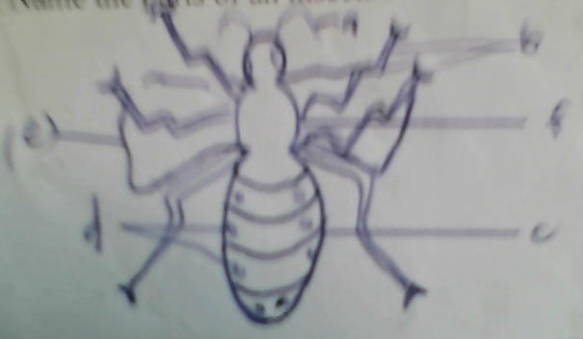

Uses of parts of an insect

Feelers /antenae- for feeling

Compound eyes – for seeing

Wings – for flying

Spiracles –for breathing

Haltere – for body balancing

Activity

1 L isten and write

A] spiracles, b] feelers , c] compound eyes, d] thorax

2 What do insects use when breathing ?

3 What is the use of feelers on an insect?

4 Name these part

REFERENCES;Mk int pri sci bk2 pg12-13

A new ug pri int sci bk2 pg 4

Und int pri sci bk2 pg 7-8

Theme;Our environment

Sub theme;common common insects

Content;characteristics of insects

I]insects have three main body parts

Ii] insects have six jointed legs

Iii] insects have exo-skeleton

Activity

1 listen and write

A] abdomen, b] thorax , c] spiracles , d]reproduce, f] exo-skeleton

2 How many parts has an insect ?

3 Write down any three characteristics of an insect

I]

Ii]

Iii

4 Menton any three body parts of an insect

I]

Ii]

Iii]

REFERENCES; Fountian pri bk 2 pg 6-7

A new ug pri sci bk2 pg 4

Mk int pri sci bk2 pg 13

THEME; Our environment

Sub theme;common insects in our environment

Content;life cycle (growth stages of insects)

A life cycle of an insect means the growth stages of an insect.

A house fly grows through four stages . Other insects which under go the same stages include;

Bees , mosquito, butterfly, and wasps.

Complete metamorphosis

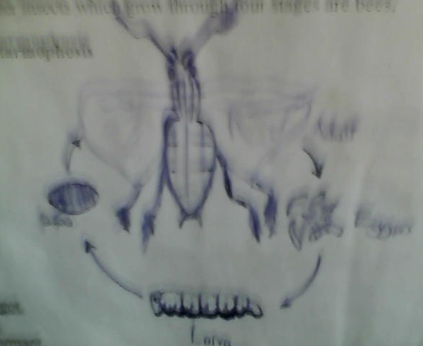

The larva of a house fly is called a maggot.

The larva of a butterfly is called a caterpillar

The pupa does not eat or move.its dormant.

Activity

Listen and write

A] larva , b] maggot ,c] pupa, d] adult e] caterpillar

2 Write any three insects which go through four stages of growth

I]

Ii]

Iii]

Iv]

3 Name the stages of the insect shown below

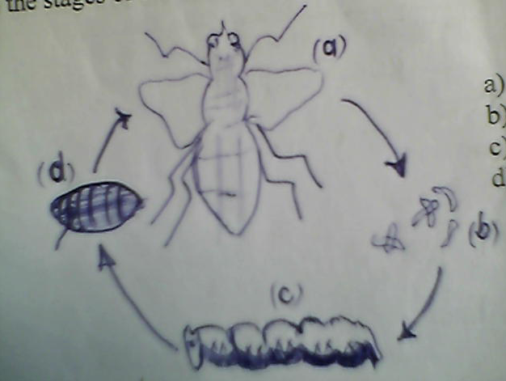

4Which stage of a house fly is dormant ?

5 A larva stage of a house fly is called?

REFERENCES; A new pri sci for ug bk2 pg 5

Fountain trs guide bk2 pg 7

Mk int pri sci bk2 pg 25

THEME; Our environment

Sub theme;common insects in our environment

Content;incomplete metamorphosis (insectwhich undergo through three stages of growth )

Some insects go through three stages of growth

These insects are; cockroaches , grasshoppers , locusts and white ants

Life cycle of a cockroach [ incomplete metamophosis ]

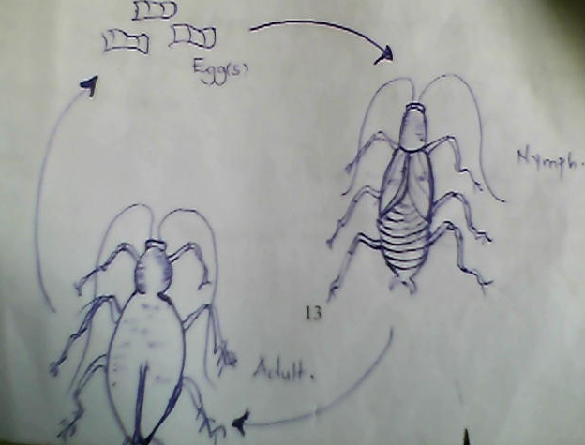

Activity

1 Listen and write

A] cockroach , b] nymph c]adult , d] egg case

2 The second stage of a cockroach is called?

3 Write down any two insects which under go incomplete metarmophosis

I]

Ii]

4 Study the diagram below and name parts labelled

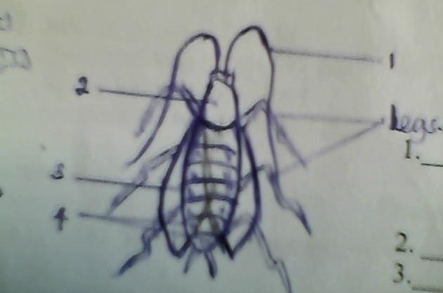

REFERENCES;Mk int pri bk2 pg 16

Und int pri bk2 pg 10

Mk int pri bk2 pg 10

THEME; Our environment

Sub theme;common insects in our environment

Content;useful insects

These are insects which are helpful to people in the environment.

Examples of useful insects

Grasshoppers

Bees

White ants

Moths

Termites

Ways in which insects are useful to people

Bees provide people with honey and wax

Some insects pollinate plants like the moth and bees

Some insects are eaten by people like grasshoppers and white ants

Some insects are used for cultural purposes.

People copy designs of insects like butterflies to make clothes.

Some insects are sold for income.

Harmful and useful insects

These are insects which useful and harmful at the same time

Like bees, and termites.

Activity

1 Listen and write

A]useful,b] harmful , c] honey ,d]destroy ,e]sting

2 Insects which are useful to people are called?

3 List down any two useful insects

I]

Ii

4 What do we get from bees?

5Write down any two insects which are harmful and useful to man

I]

Ii

6 Mention any two ways in which some insects are useful people

REFERENCES;MK int sci bk2 pg 19

A new ug pri sci bk2 pg 14

Und pri sci bk2 pg 11

THEME; Our environment

Sub theme;common insects in our environment

Content; Harmful insects

These are insects which are dangerous to people.

Examples of harmful insects

Bees

Mosquitoes

Cockroaches

Houseflies

Tsetse flies

Locusts

Wasps

Black and red ants

Termites

Insects danger

Bees/wasps sting people

Mosquitoes spread the malaria germ

Cockroaches destroy our books and clothes

House flies spread trachoma /cholera

Locusts destroy our plants

Black ants bite people

Ways in which we protect ourselves from insects.

Sleeping under mosquito nets .

Spraying using insecticides

Covering food

Slashing tall grass

Collecting broken bottles

Cleaning the compound

Burning rubbish .

Activiy

1 Listen and write

I] mosquito , b] cockroaches , c] houseflies d] tsetse flies

2 .............................................................insects are insects which are dangerous to man.

3List down any three harmful insects

I]

Ii]

Iii]

4 How can we protect ourselves from dangerous insects ?

5 Match these insects to their danger

insect danger

bees spread malaria germs

mosquito sting

cockroaches destroy our crops

housefly destroy books and clothes

locust spread cholera

REFERENCES;Mk int pri sci bk 2 pg 17

Und int bk 2 pg 11

Mk int pri bk2 pg 18

THEME; Our environment

Sub theme;common plants

Content;useful plants

These are plants which are useful to man.

Examples of useful plants

Bananas

Pineapples

Coffee

Cotton

Water melon

Millet

Cassava

Oranges

Mangoes

Avocado

Sugar cane

Uses of plants to man

i] some plants provide people with herbal medicine.

ii]some plants provide people with food.

Iii]plants act as wind breaks.

Iv]some plants provide us with timber.

V] most plants provide us with firewood.

Vi]plants provide people with oxygen

Vii]Plants give us shade.

Viii]plants help in the formation of rain fall.

Parts of a plant

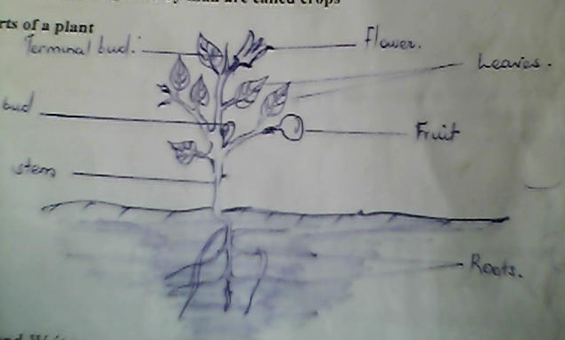

Activity

1 Listen and write

A] black jack , b] pineapple b] provide , d] oxygen e] firewood

2 What are useful plants ?

3 List down any four uses of plants to man

I]

Ii

Iii

Iv

4 Draw these parts of a plant

I] leaves

Ii] stem

C] roots

5 Mention any two plants which give us herbal medicine

I]

Ii]

REFERENCES;Mk std sst bk2 pg 48-50

Our lives today bk2 pg 44

Monitor sst bk2 pg 27

THEME; Our environment

Sub theme;common plants

Content;harmful plants

Harmful plants are plants which are dangerous to people

Examples of harmful plants

Cactus

Spear grass

Water lilly

Sisal

Dangers of plants

Some plants are poisonous

Plants with thorns prierce people

Some plants contaminate water

Activity

1 Listen and write

Harmful , poisonous ,pierce , sisal

2 Give two examples of harmful plants

I

Ii

3 Mention any two dangers of plants

I

Ii

4................................................plants are plants which are dangerous to man.

REFERENCES;Mk std sst bks pg 48-50

Our lives today pg 44

Mointor sst pg 27

THEME; Our environment

Sub theme;common plants

Content;propagation

This is the way how crops are planted

Pineapples and bananas – suckers

Sugar cane and cassava - stem cuttings

Ground nuts, onions , tomatoes ,millet and others – seeds

Sweet potatoes – vines

Activity

1 Listen and write

Propagation , pineapples , suckers , crown

2 .........................................is the way how crops are planted

3 Name any two crops propagated using seeds

I

Ii

4 Mention the plants propagated using vines

5How is a banana plant propagated?

REFERENCES; Mk in sci bk2 pg 64-66

Basic pri sci bk2 pg 9

Psc bk2 pg27

THEME; Our environment

Sub theme;common plants

Content;seeds

Types of seeds

1 Fresh seeds

2Dry seeds

3 Damaged seeds

Fresh seeds are seeds which have much water in them like frseh beans peas .

Dry seeds are seeds which have little water in them

Damaged seeds are seeds which can not germinate when planted like seeds with holes .

Activity

1 Listen and write

Damaged , fresh , seeds , germinate

2 A seed is a fertilized .................................................

3 Which type of seeds have much water in them?

4 ..............................seeds can not germinate.

5 Give any two examples of fresh seeds

I

Ii

REFERENCES;Mk int pri bk2 pg 63

Npsc for ug bk 2 pg 120-121

THEME; Our environment

Sub theme;common plants

Content;more types of seeds

Damaged seeds / bad seeds

These are seeds that can not germinate .

Viable seeds

These are seeds that can germinate.

Activity

1 Listen and write

Damaged , selection ,germinate , sorting , viable.

2........................................is the selection of good seeds from bad seeds

3damaged seeds are seeds that ..........................................................

4 Seeds that are good and can germinate are called?

THEME; Our environment

Sub theme;common plants

Content;germination

Germination is the growing of a seed into a young plant called a seedling

Conditions necessary for germination

Water / moisture

Oxygen

Warmth

Stages of germination

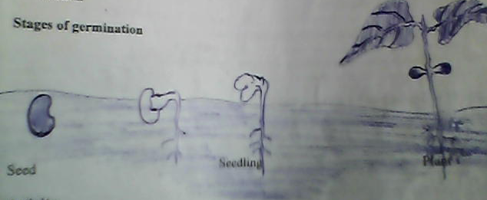

Seeds seedling plant

Activity

1 Listen and write

1 germination, b] growing c] young d] oxygen e] warmth

2 Give the conditions necessary for germination

I

Ii

Iii

REFERENCES; MK int pri sci bk2 pg58-59

THEME; Our environment

Sub theme;common plants

Content;types of soil

Clay soil

Sand soil

Loam soil

Loam soil is the best soil for growing plants .

Clay soil is used for making bricks, pots

Sand soil is for building and making glass

Activity

1 Listen and write

Loam , clay , sand

2 Mention the three types of soil

I

Ii

Iii

3 Which type of soil is the best for crop growth

4 Name the type of soil used for modelling

5Write down three types of crops grown in the swamp

I

Ii

Iii

REFERENCES; MK pri sci bk2 pg 71-73

THEME;things we make

Sub theme;things we make in the community

Content;play materials such as ropes, sticks, strings , and mats

Materials used

Banana fibre ,sisal, palm leaves, papyrus , dry soil, reeds , rubber, polythene

Sources of materials

Forests , swamps , garden and shop

Activity

1Listen and write

A] material , b] fibre , leaves ,forest, garden ,swamps

2 Draw the following

Ball

Mat

Reeds

3 Mention any two materials used to make play materials

I

Ii

4Name any two sources of materials

REFERENCES ; PSC for ug bk2 pg 29-30

Npsc for ug bk2 pg 11

THEME;things we make

Sub theme;things we make in the community

Content;kitchen

Mingling stick ,stove, plates, cups ,spoons, mortar and pestle, blender port and ladle.

Bed rooms ,mattress ,blankets , bed sheets ,pillow

Sitting room,seats , mats ,cushions,wearing ornaments feetware

Materials used

Clay , beads, wood, metal, cotton wool, plastics

Sources of materials used

Garden , swamps , forests, shop.

Activity

1 Listen and write

Kitchen , mingling stick , pestle ,cushions ornaments,

2 Mention two materials used to make things used at home

I

Ii

3 Menton any two things found in the bed room

I

Ii

4Draw these things found in the kitchen

Mingling stick , pestle , ladle

REFERENCES;

THEME;things we make

Sub theme;things we make in the community

Content;importance of things we make

A mingling stick for mingling

Pots for cooking ,fetching and storing water

Play things like ropes,balls and sticks

Earning a living

Decoration

Promotion of cultural heritage and skills

Promotes learning

Activity

Listen and write

Mingling, earning , decoration, beauty

2 Give two things used for playing

I

Ii

3 Mention any two things sold to earn a living

I

Ii

4 Draw and name any two things made at home

i

Ii

REFERENCES; PSC FOR UG bk2 pg 20

THEME;transport in our communirty

Sub theme;means of transport

Content;means and uses of transport in our community

Transport is the movement of people ,animals and their goods from one place to another.

Types of transport

Air transport, aeroplanes ,parachute, rocket,helicopter,mig

Water transport,ferry, ship, boat canoe , submarine,yacht

Road transport , car lorry ,bus , taxi, bicycle ,motorcycle, camel, donkey.

Railway transport,train

Road transport is the commonest and mostly used by many people.

Air transport is the most expensive/fastest type of transport.

Water transport is the cheapest type of transport.

Railway transport is the slowest type of transport.

Activity

1 Listen and write

Aeroplane,transport, raiyway, lorry, road.

2...........................................is the commonest type of transport

3The use of transport is to ..............................people and their goods from one place to another.

4 ,,,,,,,,,,,,,,,,,,,,,,,,,,,,,,,,,,,is the quickest type of transport

5 Draw an aeroplane

REFERENCES ;PSC book2 pg 32

Monitor sst bk 2 pg 49

THEME;transport in our communirty

Sub theme;road safety

Content;proper use of road signs

Examples of road signs

Humps ahead

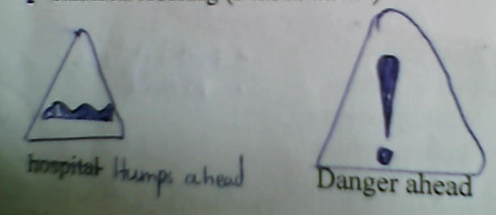

Zebra crossing

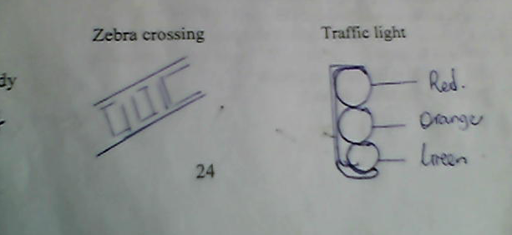

Traffic lights

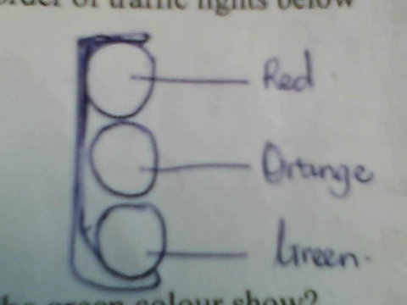

Parking

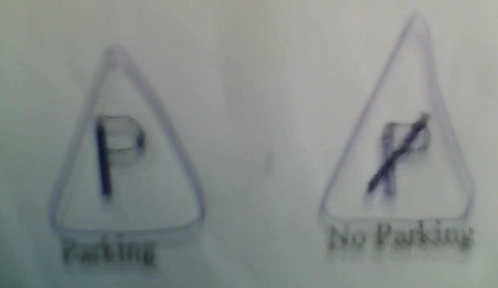

No parking

Danger ahead

Children crossing

Activity

1 Listen and write

Danger ahead,zebra crossing

Parking

Np parking

2 Name the order of traffic lights below

3What do these colours mean

Red

Orange

Green

THEME;transport in our communirty

Sub theme;road safety

Content;safe ways of using the road

Observing traffic rules and signs

Waking in single lines

Using a zebra crossing

Drive cars in good mechanical condition

Do not drink and drive

Do not over load

Un safe ways of using the road

Playing on the road

Over loading

Drinking while driving

Over speeding

Throwing objects at moving vehicles.

Crossing where roads meet,near a bend, at ajunction,near the top of a hill,between parked cars and grazing along the road.

Activity

1 Listen and write

Walking , loading , zebra crossing

2 Give two way of using the road

I

Ii

3 Where should we cross the busy road from ?

4 Mention two unsafe ways of using the road

I

Ii

5 Mention the quickest type of transport

REFERENCES ;Monitor sst bk2 pg 49

Our lives today page 42-43

THEME;transport in our community

SUB THEME;Unsafe ways of using the road

CONTENT;Dangerous things on the road

Landslides/falling rocks,pot holes,broken bottles,water passages,nails,water,land mines,waste disposal broken electric wires ,

People who help in traffic

Police man/woman,parents ,teachers,older children,wardens,lollipop men/women.

Activity

1) Mention any three dangerous things found on the road.

I

Ii

Iii

2) List down atleast four people who help on the road.

I

Ii

Iii

Iv

Reference;psc for Uganda bk 2 page 33

THEME;transport in our communirty

Sub theme;road safety

Content;causes of common accidents in the community

Poor housing medicine

Poison sharp objects

Vehicles hot objects

Violence insects

Irresponsibilty water

Animals

Activity

1 Listen and write

Fire , poison, vehicles, behavior

2Mention two examples of common accidents

3 Give two ways we can avoid common accidents

I

Ii

5 Name the vehicle which carries sick and injuried people to the hospital

REFERENCES;COMP, sst bk2 pg 59

Our lives today bk2 pg 43

THEME;transport in our communirty

Sub theme;road safety

Content;ways of managing accidents;

Reporting

Rushing to hospital

Good feeding

Using bandages

Follow instructions on medicines

Cleaning daily

Keeping things safe

Activity

1 listen and write

Rushing , report , feeding , daily

2 Mention any two common accidents

I

Ii

3 Give two causes of common accidents

I

Ii

4 Name four ways in which we manage accidents

I

Ii

Iii

Iv

REFERENCES; NPSC FOR UG

THEME;Accidents and safety

Sub theme;First aid

Content; what is first aid

This is the first help given to a casualty before being taken to hospital.

Why do we give first aid?

To save life

To promote recovery

To reduce bleeding

To prevent further injury

To reduce pain

Examples of first aid

Applying a cold pad

Disconnect circuits

Tying the bitten part

Giving a lot of cold drinks

Activity

1 Listen and write

Casualty , hospital, disconnect

2.why do we give first aid ?

3 mention three forms of first aid

I]

Ii]

Iii]

4 What immediate help can you give to a person who has been bitten by a snake?

REFERENCES;psc for ug bks 35

Npsc for ug pg 132